**Apple Pie**

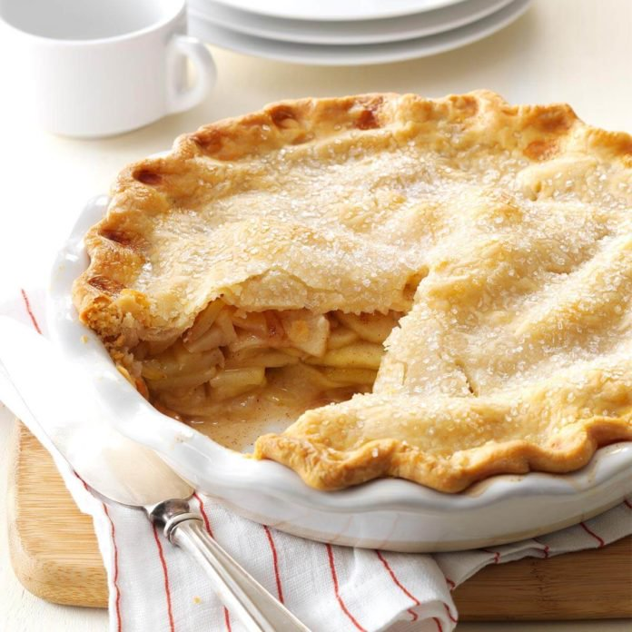

## *An apple pie is a pie or a tart, in which the principal filling ingredient is apple. It is, on occasion, served with whipped cream or ice cream on top.*

## Ingredients

* 1/2 cup sugar
* 1/2 cup packed brown sugar
* 3 tablespoons all-purpose flour
* 1 teaspoon ground cinnamon
* 1/4 teaspoon ground ginger
* 1/4 teaspoon ground nutmeg
* 6 to 7 cups thinly sliced peeled tart apples
* 1 tablespoon lemon juice
* Pastry for double-crust pie (9 inches)
* 1 tablespoon butter
* 1 large egg white
* Additional sugar

## Directions

1. In a small bowl, combine the sugars, flour and spices; set aside. In a large bowl, toss apples with lemon juice. Add sugar mixture; toss to coat.
2. Line a 9-in. pie plate with bottom crust; trim even with edge. Fill with apple mixture; dot with butter. Roll remaining crust to fit top of pie; place over filling. Trim, seal and flute edges. Cut slits in crust.
3. Beat egg white until foamy; brush over crust. Sprinkle with sugar. Cover edges loosely with foil.
4. Bake at 375° for 25 minutes. Remove foil and bake until crust is golden brown and filling is bubbly, 20-25 minutes longer. Cool on a wire rack.

**See other Recipes -> https://www.tasteofhome.com/**